Data Communication and Networks

Lab experiment 06

Name - Naman Dixit

Sap ID - 500125539

Batch - 7 Data Science



#Wireless Local Area Network

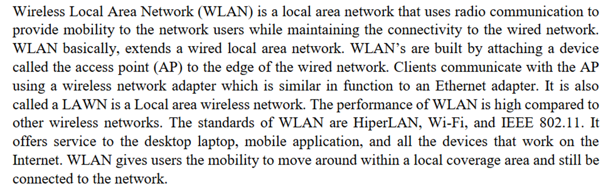

#Objective



#Procedure



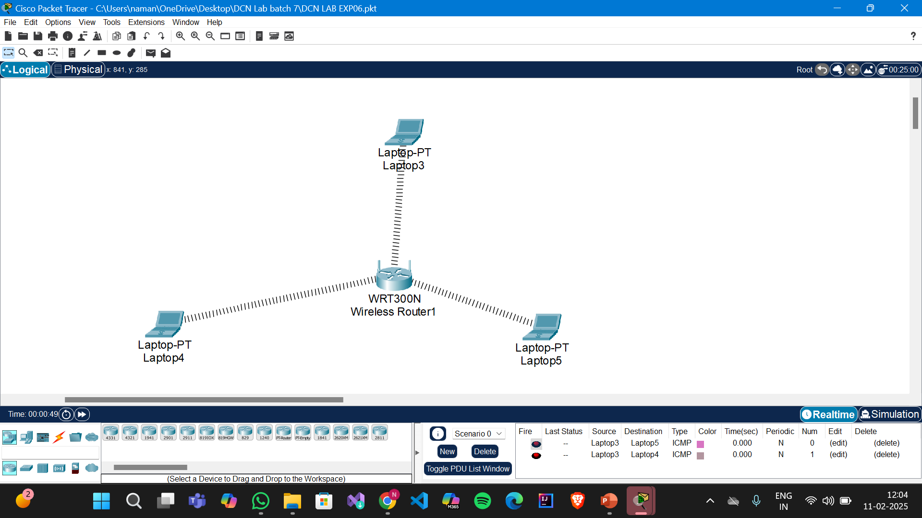



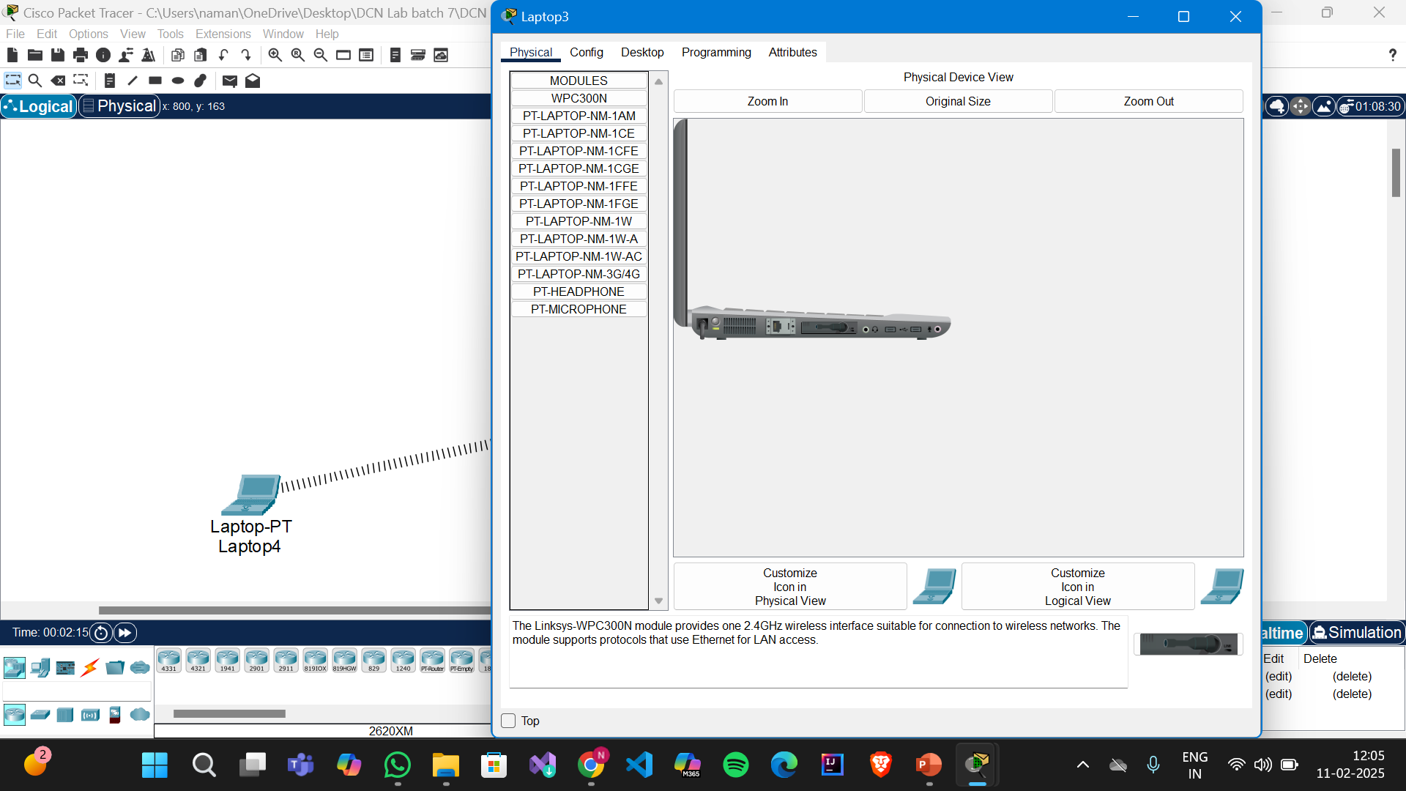

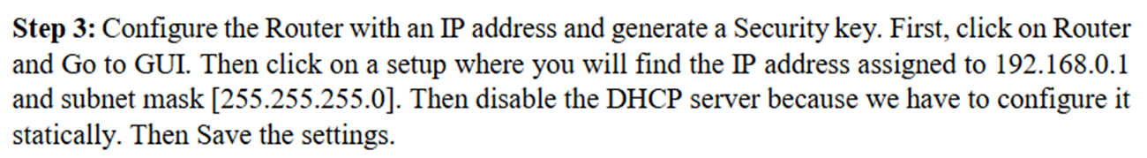

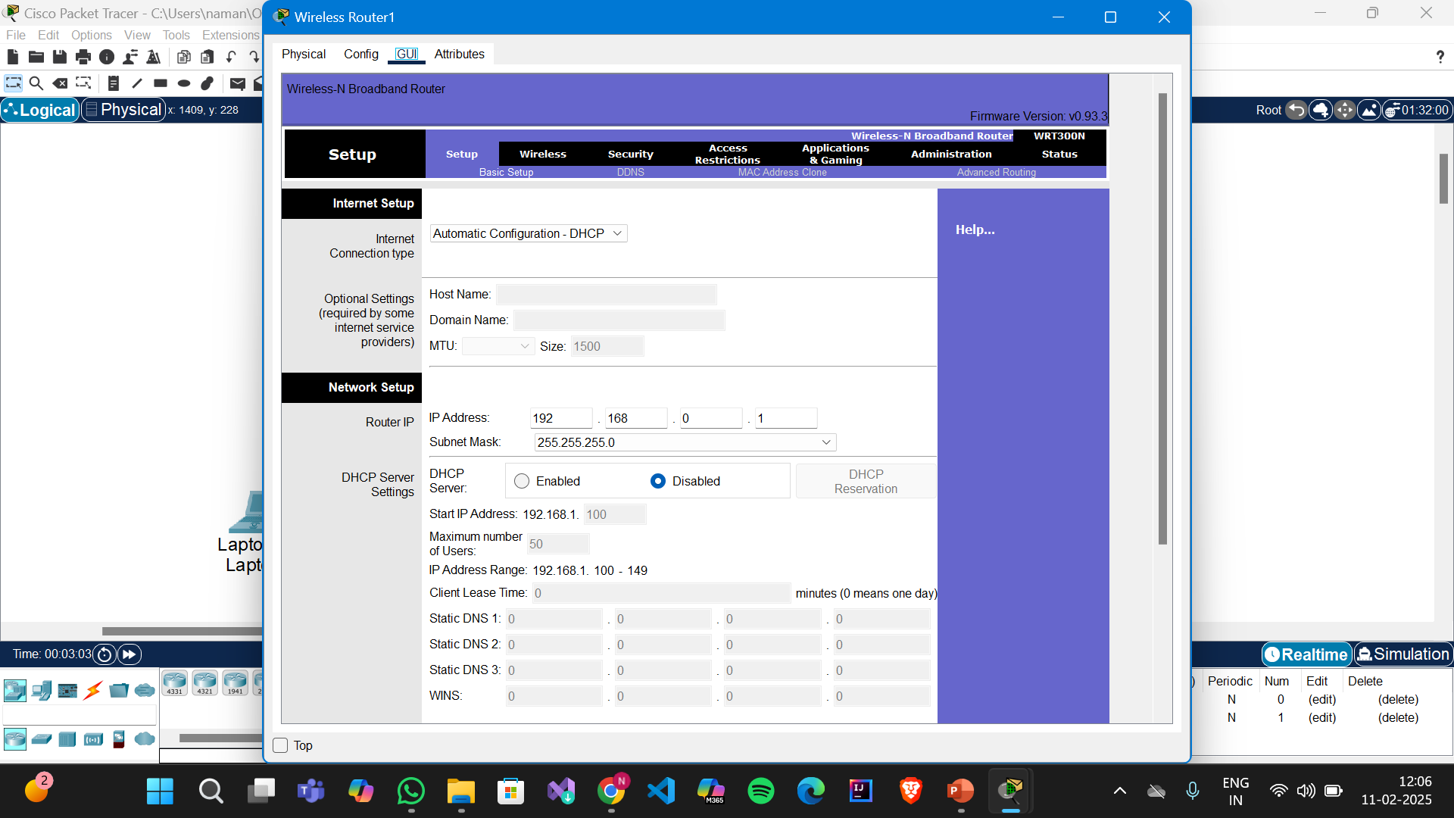

Then move to the wireless option, and set Network Name(SSID) as MYnetwork. Save the settings

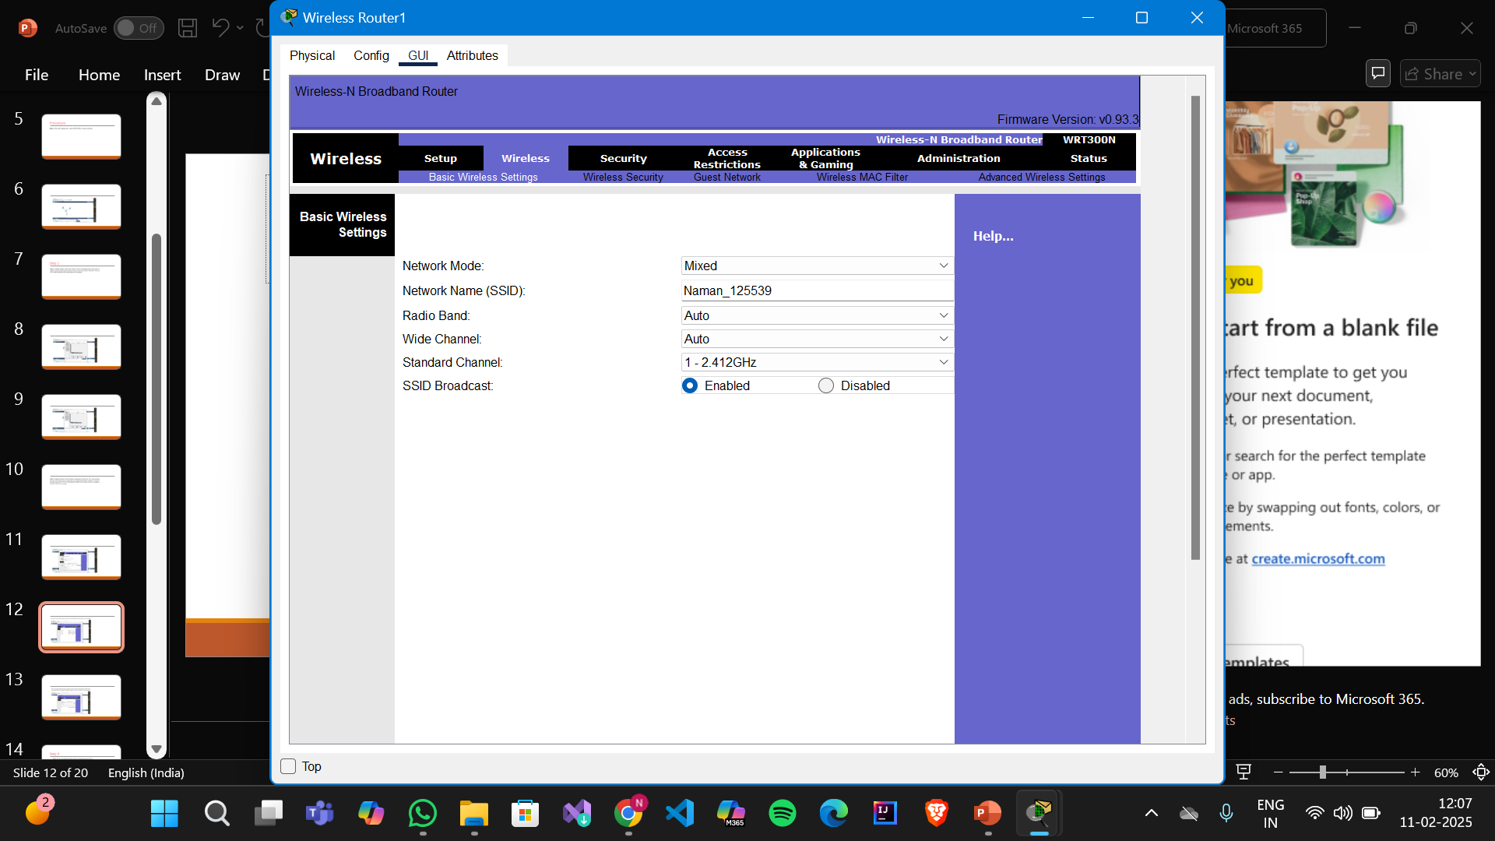

Then we set the security key. Click on wireless security and select security mode as WEP.Then we’ll generate KEY by entering 10 digit Hexa-numeric value. Eg. 0123456789.Save the settings.

